R Road Trip Home Animal Rescue
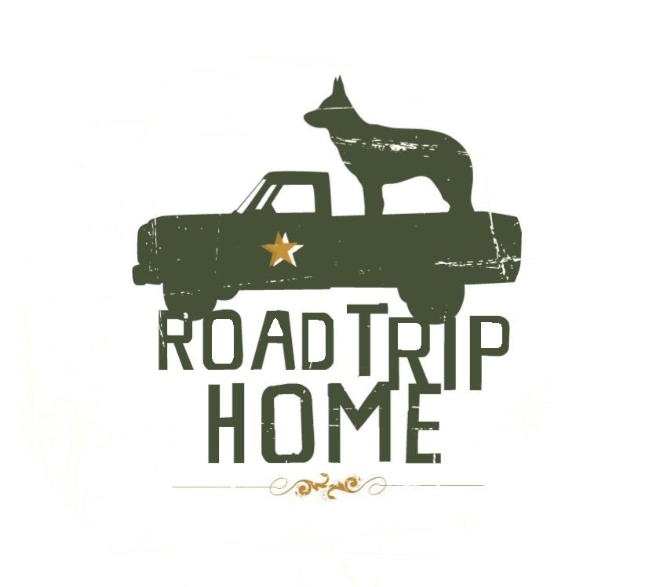
PO Box 372
Acworth, GA 30101
Volunteer Waiver

I acknowledge that I and/or my child will be directly handling dogs and cats of unknown histories, origins and tendencies and as such, will exercise caution in my/our encounters and take personal responsibility for any scratches, bites, nips, falls, abrasions, etc. that may occur as a result of my/our participation. I further acknowledge that working within the Road Trip Home quarantine room at Lake City Animal Hospital I may encounter airborne illnesses which may carried home to my pets. I will take the necessary precautions to ensure that this does not happen and follow all of Lake City Animal Hospital’s guidelines for cleanliness when entering and exiting the Road Trip Home Quarantine Room.
I acknowledge that I am at least 18 years of age. I hereby release Road Trip Home, its volunteers, officers, board of directors and Lake City Animal Hospital and its employees from any and all liability for personal injury which I may sustain and/or any damage and/or loss to my personal property during the course of my activities as a volunteer
If under the age of 18, my parent or guardian will sign below and accompany me at all times while volunteering at Lake City Animal Hospital. A designated supervisor may stand in for volunteering at our fundraising events after a signed waiver by the parent has been submitted.
I (the parent/guardian) agree to the aforementioned and in addition release Road Trip Home, its volunteers, officers, board of directors and Lake City Animal Hospital and its employees, from any and all liability which the minor in my charge may sustain and/or damage and/or loss to their personal property during the course of any minor’s activities as a volunteer.
I have read, understood and agree to the above.
___________________________________________ ________________________________________
SIGNATURE OF VOLUNTEER PRINT NAME

DATE ____________ PHONE _________________ EMAIL ADDRESS _____________________________

____________________________________________ ________________________________________
SIGNATURE OF PARENT/GUARDIAN (IF UNDER 18) PRINT NAME

ADDRESS, CITY, STATE, ZIP _______________________________________________________________

Volunteer Waiver 5/18/2011

